‘Remembering the Past: Building the Future’
An International workshop on Reminiscence Arts including lectures and theatre presentations on
9th December 2016, 10-5pm at the University of Greenwich, Bathway, Woolwich SE18 6QX

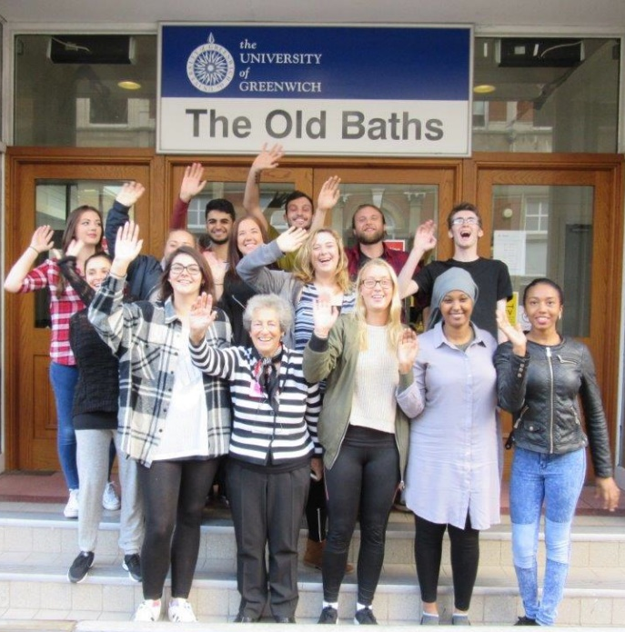

This workshop at the University of Greenwich will showcase and share work generated by the European Reminiscence Network and the University of Greenwich Drama and History programmes as a part of the international Europe for Citizens project, ‘Remembering the Past: Building the Future’.

The event is free, including lunch, tea and coffee, but donations are very welcome.
Delegates to the event will participate in all parts of the day through discussion and through sharing their own work in the field, both informally and through public plenary sessions. All enquiries to Pam Schweitzer at pam@pamschweitzer.com
In the morning, there will be presentations from the international project, with papers from our partners from Dresden (Germany) Budapest (Hungary) Wroclaw (Poland) Thessaloniki (Greece) and Greenwich (UK).

In the afternoon we shall showcase some of the resulting intergenerational Reminiscence Theatre and Theatre-in-Education work it has given rise to in London: Students of Drama and History from the University of Greenwich, older people from the Greenwich Pensioners Forum and local schools will participate.
The theme of the UK partner in the project ‘Remembering the Past: Building the Future’ is wartime evacuation. In 1939, many thousands of London children were removed from their parents and sent miles away, to escape the bombing. They lived with ‘billet families’ in the safety of the English countryside, many staying there until 1945, when they returned to a war-torn London and had to get to know their own parents all over again.
During this autumn term, Drama and History students at the University of Greenwich will be recording memories of wartime evacuees and using the Reminiscence Theatre Archive as a source of stories. Their research will form the basis of two theatre shows to be created by the students and an illustrated booklet of memories.
One show will be aimed at audiences of older people, designed to jog their memories of the war years, and stimulate a sharing of experience. The other show will be aimed at children aged 8-11 in London primary schools, designed to increase their knowledge and understanding of the period through the experiences of those who lived through it. Older people will be involved in both projects as story-tellers and sometimes as performers.

