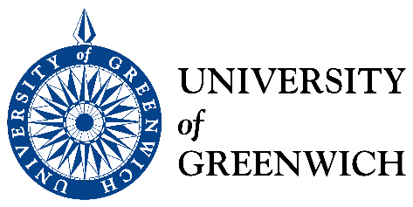
The European Reminiscence Network and the University of Greenwich present:
MEMORY GRAND CHALLENGE:
Exploring links between reminiscence in dementia care and oral history
A seminar to be held at the University of Greenwich on
Thursday 13th October from 3pm to 6pm
Room QA063, Old Royal Naval College, 30 Park Row, London SE10 9LS
Over the last three years, key members of the Oral History Society have participated in a new Training and Apprenticeship scheme in Reminiscence in Dementia Care. They have worked with older people with dementia and their family carers revisiting the key stages in their lives using creative arts-based approaches in order to support the sense of identity and self-worth of the participants.
The results of this work have been significant for the families involved.
- What are the links between this highly personal exploration of life stories in a group of families living with dementia and the more conventional role of the oral historian?
- What are the effects of this activity on the participating people with dementia and their family carers in terms of how they see their own past and present lives?
- What are the effects on oral historians of working so closely with people with dementia and could it affect their future practice?
- Whose ‘truth’ is shared in these life-course sessions?
- How do we make the process of remembering together in these sessions into a memorable product?
In this workshop, we shall hear from the following Oral Historians:
Dvora Liberman, Sarah Gudgin, Padmini Broomfield
and the following family carers:
Kate White, Robbie Wick and Kate Harwood
The session will be led by Pam Schweitzer, Director European Reminiscence
Network and Honorary Research Fellow, University of Greenwich
We hope this event will be of interest to members of the newly-formed special interest group of the Oral History Society as well as to University of Greenwich staff and students.
To book your place please email: pam@pamschweitzer.com or bj61@gre.ac.uk

